Bangladesh Medical Association (BMA)
List of Life Member-272
04. BMA Barishal Branch

Sl No | Voter No | Voter Details
1 | Voter No  LM-0400001  No Image | DR. KAMALENDU BISWAS  F/Name:  M/Name:  BM & DC Reg. No:  NID:  Cell:  Address: 3/D, Doctor's Quarter Sagardi, Barisal.  Blood Group:
2 | Voter No  LM-0400002  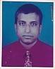 | DR. A.K.M. AMINUL HOQUE  F/Name: Late Intazuddin Howlader  M/Name:  BM & DC Reg. No:  NID:  Cell:  Address: Sher-E-Bangla Medical College Barisal  Blood Group:
3 | Voter No  LM-0400003  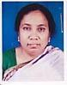 | DR. SELINA PARVIN  F/Name:  M/Name:  BM & DC Reg. No:  NID:  Cell:  Address: C/O, Mr. Shamsuddin Ahmed, R.S (Gynae & Obs) Shar-E-Bangla Medical College Barisal  Blood Group:
4 | Voter No  LM-0400004  No Image | DR. SYED REZAUL KARIM  F/Name:  M/Name:  BM & DC Reg. No:  NID:  Cell:  Address: Asstt. Prof. (Neuro) Medicine Shar-E-Bangla Medical College Barisal  Blood Group:
5 | Voter No  LM-0400005  No Image | DR. ABU SALEH MOHD. WALIULLAH  F/Name:  M/Name:  BM & DC Reg. No:  NID:  Cell:  Address:  Blood Group:  TRANSFERED to BMA Dhaka City  LM-1405543
6 | Voter No  LM-0400006  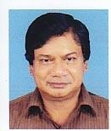 | DR. AZIZ RAHIM  F/Name:  M/Name:  BM & DC Reg. No:  NID:  Cell:  Address: Club Road Gordan Compound Barisal  Blood Group:
7 | Voter No  LM-0400007  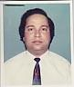 | DR. MD. NAZRUL ISLAM (SALIM)  F/Name:  M/Name:  BM & DC Reg. No:  NID:  Cell:  Address: Padmabati Road Barisal  Blood Group:
8 | Voter No  LM-0400008  No Image | DR. M.K. IZHARUL QUAYYUM CHOWDHURY  F/Name:  M/Name:  BM & DC Reg. No:  NID:  Cell:  Address: Shar-E-Bangla Medical College Barisal  Blood Group:
9 | Voter No  LM-0400009  No Image | DR. K.B.M. ABDUR RAHMAN  F/Name:  M/Name:  BM & DC Reg. No:  NID:  Cell:  Address:  Blood Group:  TRANSFERED to BMA Dhaka City  LM-1405543
10 | Voter No  LM-0400010  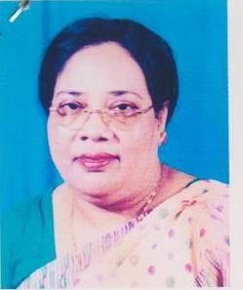 | DR. BEGUM ROWSHAN ARA  F/Name:  M/Name:  BM & DC Reg. No:  NID:  Cell:  Address: Assistant Professor (Gynae Obs.) Shar-E-Bangla Medical College Barisal  Blood Group:
11 | Voter No  LM-0400011  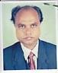 | DR. ALTAF UDDIN AHMED  F/Name:  M/Name:  BM & DC Reg. No:  NID:  Cell:  Address: Sadar Hospital Barisal  Blood Group:
12 | Voter No  LM-0400012  No Image | DR. MD. SANAWAR HOSSAIN  F/Name:  M/Name:  BM & DC Reg. No:  NID:  Cell:  Address: Prof. Of Surgery Shar-E-Bangla Medical College Barisal  Blood Group:
13 | Voter No  LM-0400013  No Image | DR. SULTANA RAZIA BEGUM  F/Name:  M/Name:  BM & DC Reg. No:  NID:  Cell:  Address: Prof. Of Gynae & Obs. Shar-E-Bangla Medical College Barisal  Blood Group:
14 | Voter No  LM-0400014  No Image | DR. SHISHIR KUMAR MOJUMDER  F/Name:  M/Name:  BM & DC Reg. No:  NID:  Cell:  Address: Prof. Community Medicine, Dhaka National Medical College, 53/1, Johnson Road, Dhaka.  Blood Group:  TRANSFERED to BMA Dhaka City  LM-1405543
15 | Voter No  LM-0400015  No Image | DR. MD. ABDUL LATIF  F/Name:  M/Name:  BM & DC Reg. No:  NID:  Cell:  Address: Shar-E-Bangla Medical College Barisal  Blood Group:
16 | Voter No  LM-0400016  No Image | DR. FARIDA ADIB KHANUM  F/Name:  M/Name:  BM & DC Reg. No:  NID:  Cell:  Address:  Blood Group:  TRANSFERED to BMA Dhaka City  LM-1405543
17 | Voter No  LM-0400017  No Image | DR. MD. ABDUL HALIM KHAN  F/Name:  M/Name:  BM & DC Reg. No:  NID:  Cell:  Address:  Blood Group:  TRANSFERED to BMA Dhaka City  LM-1405543
18 | Voter No  LM-0400018  No Image | DR. MD. SHELIM BHUIYAN  F/Name:  M/Name:  BM & DC Reg. No:  NID:  Cell:  Address: New Al Razi Hospital Pvt. Ltd. 32, Green Road 2nd Floor, Dhanmondi, Dhaka.  Blood Group:  TRANSFERED to BMA Dhaka City  LM-1405543
19 | Voter No  LM-0400019  No Image | DR. MD. NAZRUL ISLAM  F/Name:  M/Name:  BM & DC Reg. No:  NID:  Cell:  Address: Associate Prof., Anatomy Shar-E-Bangla Medical College Barisal  Blood Group:
20 | Voter No  LM-0400020  No Image | DR. MD. SHAH ALAM  F/Name:  M/Name:  BM & DC Reg. No:  NID:  Cell:  Address: Associate Prof. Forensic Medicine Chandra Para, Bhatikhana Barisal  Blood Group:
21 | Voter No  LM-0400021  No Image | DR. MAINUDDIN AHMED  F/Name:  M/Name:  BM & DC Reg. No:  NID:  Cell:  Address: 3/D, Doctor's Quarter Shar-E-Bangla Medical College Barisal  Blood Group:
22 | Voter No  LM-0400022  No Image | DR. SAROJ KUMAR DASS  F/Name:  M/Name:  BM & DC Reg. No:  NID:  Cell:  Address: Associate Professor Of Psychiatry Shar-E-Bangla Medical College Barisal  Blood Group:
23 | Voter No  LM-0400023  No Image | DR. NASIRUDDIN AHMED  F/Name:  M/Name:  BM & DC Reg. No:  NID:  Cell:  Address: Associate Prof. Pathology Shar-E-Bangla Medical College Barisal  Blood Group:
24 | Voter No  LM-0400024 | DR. BARUN KUMAR BOSE  F/Name:  M/Name:  BM & DC Reg. No:  NID:  Cell:  Address: K.B.F.H Road Barisal  Blood Group:
25 | Voter No  LM-0400025 | DR. MD. SHAH ALAM  F/Name:  M/Name:  BM & DC Reg. No:  NID:  Cell:  Address: 6/F, Doctor's Quarter Sagardi Barisal  Blood Group:
26 | Voter No  LM-0400026  No Image | DR. FARIDUL ISLAM  F/Name:  M/Name:  BM & DC Reg. No:  NID:  Cell:  Address: Dept. Of Medicine Shar-E-Bangla Medical College Barisal  Blood Group:  TRANSFERED to BMA Dhaka City  LM-1405543
27 | Voter No  LM-0400027  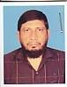 | DR. ABRAR AHMED  F/Name:  M/Name:  BM & DC Reg. No:  NID:  Cell:  Address: 4/C, Doctor's Quarter Shar-E-Bangla Medical College Barisal  Blood Group:
28 | Voter No  LM-0400028  No Image | DR. M.A. KHALILUR RAHMAN  F/Name:  M/Name:  BM & DC Reg. No:  NID:  Cell:  Address: Asstt. Prof. Dermatology Shar-E-Bangla Medical College Barisal  Blood Group:
29 | Voter No  LM-0400029  No Image | DR. MOLLAH OBAYEDULLAH BAKI  F/Name:  M/Name:  BM & DC Reg. No:  NID:  Cell:  Address: Barishal  Blood Group:  TRANSFERED to BMA Dhaka City  LM-1405543
30 | Voter No  LM-0400030  No Image | DR. MD. SALIM REZA  F/Name:  M/Name:  BM & DC Reg. No:  NID:  Cell:  Address: 4/A, Doctor's Quarter Shar-E-Bangla Medical College Barisal  Blood Group:
31 | Voter No  LM-0400031  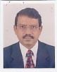 | DR. GHULAM MOHAMMOD SELIM  F/Name:  M/Name:  BM & DC Reg. No:  NID:  Cell:  Address: Asstt. Prof. Neuro Medicine Shar-E-Bangla Medical College Barisal  Blood Group:
32 | Voter No  LM-0400032  No Image | DR. MD. ABDUL HAYEE  F/Name:  M/Name:  BM & DC Reg. No:  NID:  Cell:  Address:  Blood Group:  TRANSFERED to BMA Dhaka City  LM-1405543
33 | Voter No  LM-0400033  No Image | DR. MD. MOKHLESS UDDIN  F/Name:  M/Name:  BM & DC Reg. No:  NID:  Cell:  Address: Minar House 128/1  Central Bashaboo,  Dhaka.  Blood Group:  TRANSFERED to BMA Dhaka City  LM-1405543
34 | Voter No  LM-0400034  No Image | DR. MD. MUJIBUR RAHMAN  F/Name:  M/Name:  BM & DC Reg. No:  NID:  Cell:  Address:  Blood Group:  TRANSFERED to BMA Dhaka City  LM-1405543
35 | Voter No  LM-0400035  No Image | DR. MD. GOLAM RABBAIN  F/Name:  M/Name:  BM & DC Reg. No:  NID:  Cell:  Address: Dept. Of Community Medicine Shar-E-Bangla Medical College Barisal  Blood Group:
36 | Voter No  LM-0400036  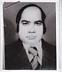 | DR. MD. YOUSUF ALI  F/Name:  M/Name:  BM & DC Reg. No:  NID:  Cell:  Address: Anatomy Dept Shar-E-Bangla Medical College Barisal  Blood Group:
37 | Voter No  LM-0400037  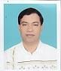 | DR. MANABENDRA SARKER  F/Name:  M/Name:  BM & DC Reg. No:  NID:  Cell:  Address: 6/D, Doctor's Quarter Sher-E-Bangla Medical College Barisal  Blood Group:
38 | Voter No  LM-0400038  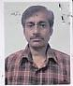 | DR. ADI MUJAHID UDDIN AHMAD  F/Name:  M/Name:  BM & DC Reg. No:  NID:  Cell:  Address: Janakisang Road Barisal  Blood Group:
39 | Voter No  LM-0400039  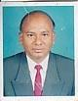 | DR. MD. JAHANGIR ALAM  F/Name:  M/Name:  BM & DC Reg. No:  NID:  Cell:  Address: Lecturer, Anatomy Dept. Shar-E-Bangla Medical College Barisal  Blood Group:
40 | Voter No  LM-0400040  No Image | DR. MD. GOLAM ROHMAN  F/Name:  M/Name:  BM & DC Reg. No:  NID:  Cell:  Address: Medical Officer, Anatomy Dept. Sher-E-Bangla Medical College Barisal.  Blood Group:
41 | Voter No  LM-0400041  No Image | DR. BABUL KUMAR SAHA  F/Name:  M/Name:  BM & DC Reg. No:  NID:  Cell:  Address: 6/E, Aziz Co-Operative Society Shahbagh Dhaka.  Blood Group:  TRANSFERED to BMA Dhaka City  LM-1405543
42 | Voter No  LM-0400042  No Image | DR. DULARI BEGUM  F/Name:  M/Name:  BM & DC Reg. No:  NID:  Cell:  Address: 4/C, Doctor's Quarter Sher-E-Bangla Medical College Barisal  Blood Group:
43 | Voter No  LM-0400043  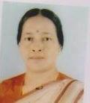 | DR. SONALI SEN GUPTA  F/Name:  M/Name:  BM & DC Reg. No:  NID:  Cell:  Address: Lecturer, Pharmacology Sher-E-Bangla Medical College Barisal  Blood Group:
44 | Voter No  LM-0400044  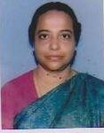 | DR. SYEDA HOSNE-ARA  F/Name:  M/Name:  BM & DC Reg. No:  NID:  Cell:  Address: 4/E, Doctor's Quarter Sher-E-Bangla Medical College Barisal  Blood Group:
45 | Voter No  LM-0400045  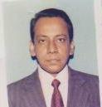 | DR. MD. KAMRUL HASSAN (SALIM)  F/Name:  M/Name:  BM & DC Reg. No:  NID:  Cell:  Address: 4/E, Doctor's Quarter Sher-E-Bangla Medical College Barisal  Blood Group:
46 | Voter No  LM-0400046  No Image | DR. KAZI YEASMIN SATTER  F/Name:  M/Name:  BM & DC Reg. No:  NID:  Cell:  Address:  Blood Group:  TRANSFERED to BMA Dhaka City  LM-1405543
47 | Voter No  LM-0400047  No Image | DR. NAHREEN AKHTER (NASIM)  F/Name:  M/Name:  BM & DC Reg. No:  NID:  Cell:  Address:  Blood Group:  TRANSFERED to BMA Dhaka City  LM-1405543
48 | Voter No  LM-0400048  No Image | DR. NAGMUN NAHAR  F/Name:  M/Name:  BM & DC Reg. No:  NID:  Cell:  Address: Curator, Pathology Dept. SHER-E-BANGLA MEDICAL COLLEGE Barisal  Blood Group:
49 | Voter No  LM-0400049  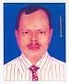 | DR. S.M. IQBALUR RAHMAN SIKDER  F/Name:  M/Name:  BM & DC Reg. No:  NID:  Cell:  Address: Lecturer Of Pathology Sher-E-Bangla Medical College Barisal  Blood Group:
50 | Voter No  LM-0400050  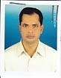 | DR. M.T. JAHANGIR HUSSAIN  F/Name:  M/Name:  BM & DC Reg. No:  NID:  Cell:  Address: Lecturer Pathology Sher-E-Bangla Medical College Barisal  Blood Group:
51 | Voter No  LM-0400051  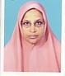 | DR. ASMA BEGUM  F/Name:  M/Name:  BM & DC Reg. No:  NID:  Cell:  Address: Lecturer Comm Medicine Sher-E-Bangla Medical College Barisal  Blood Group:
52 | Voter No  LM-0400052  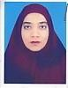 | DR. AKHTARI KHANAM  F/Name:  M/Name:  BM & DC Reg. No:  NID:  Cell:  Address: Kohinoor Villa Bangla Bazar Barisal  Blood Group:
53 | Voter No  LM-0400054  No Image | DR. SUDHANGSHU KUMAR BALLAV  F/Name:  M/Name:  BM & DC Reg. No:  NID:  Cell: 01720500411  Address: Prof. Of ENT Khulna Medical College, Khulna  Blood Group:  TRANSFERED to BMA Dhaka City  LM-1405543
54 | Voter No  LM-0400055  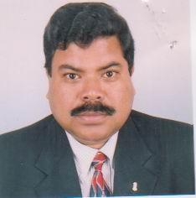 | DR. NIZAMUDDIN FARUQUE  F/Name:  M/Name:  BM & DC Reg. No:  NID:  Cell:  Address: Res. Surgeon (Eye) Sher-E-Bangla Medical College Barisal  Blood Group:
55 | Voter No  LM-0400056  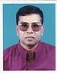 | DR. MD. ATAUR RAHMAN CHUNNU  F/Name:  M/Name:  BM & DC Reg. No:  NID:  Cell:  Address: Eye OPD Sher-E-Bangla Medical College Barisal  Blood Group:
56 | Voter No  LM-0400057  No Image | DR. HALIMA SAIDYA BEGUM  F/Name:  M/Name:  BM & DC Reg. No:  NID:  Cell:  Address: Baptist Mission Road Barisal  Blood Group:
57 | Voter No  LM-0400058  No Image | DR. MD. JAHANGIR HOSSAIN  F/Name:  M/Name:  BM & DC Reg. No:  NID:  Cell:  Address: Sadhan Mansion, Amtala, Barisal  Blood Group:
58 | Voter No  LM-0400059  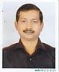 | DR. RANAJIT KUMAR MOLLICK  F/Name:  M/Name:  BM & DC Reg. No:  NID:  Cell:  Address: Resident Surgeon, General Sher-E-Bangla Medical College Barisal  Blood Group:
59 | Voter No  LM-0400060  No Image | DR. GULZAR RAHMAN  F/Name:  M/Name:  BM & DC Reg. No:  NID:  Cell: 01711953059  Address: Road # 6, House # 25 Sonadanga R/A. Khulna.  Blood Group:  TRANSFERED to BMA Dhaka City  LM-1405543
60 | Voter No  LM-0400061  No Image | DR. PIJUSH KANTI DAS  F/Name:  M/Name:  BM & DC Reg. No:  NID:  Cell:  Address: R.S. Casualty SHER-E-BANGLA MEDICAL COLLEGE Barisal  Blood Group:
61 | Voter No  LM-0400062  No Image | DR. A.K.M. NIZAM-UL-ISLAM  F/Name:  M/Name:  BM & DC Reg. No:  NID:  Cell:  Address:  Blood Group:  TRANSFERED to BMA Dhaka City  LM-1405543
62 | Voter No  LM-0400063  No Image | DR. M. NARUL ISLAM CHUNNU  F/Name:  M/Name:  BM & DC Reg. No:  NID:  Cell:  Address: 5/C, Doctor's Quarter Sher-E-Bangla Medical College Barisal  Blood Group:
63 | Voter No  LM-0400064  No Image | DR. S.M. MUNEERUZZAMAN  F/Name:  M/Name:  BM & DC Reg. No:  NID:  Cell:  Address: Barishal  Blood Group:  TRANSFERED to BMA Dhaka City  LM-1405543
64 | Voter No  LM-0400065  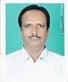 | DR. MD. MAHBUBUL ALAM  F/Name:  M/Name:  BM & DC Reg. No:  NID:  Cell:  Address: Mitu Mansion Police Line Road Barisal  Blood Group:
65 | Voter No  LM-0400066  No Image | DR. SYED MD. IDRIS ALI  F/Name:  M/Name:  BM & DC Reg. No:  NID:  Cell:  Address: Anaesth Dept. Sher-E-Bangla Medical College, Barisal.  Blood Group:  TRANSFERED to BMA Dhaka City  LM-1405543
66 | Voter No  LM-0400067  No Image | DR. MAHBUB MORSHED  F/Name:  M/Name:  BM & DC Reg. No:  NID:  Cell:  Address: Asstt. Registrar Sher-E-Bangla Medical College Barisal  Blood Group:
67 | Voter No  LM-0400068  No Image | DR. MD. MAINUL AHSAN  F/Name:  M/Name:  BM & DC Reg. No:  NID:  Cell:  Address: IMO. Ortho Surgery Dept. Sher-E-Bangla Medical College Barisal  Blood Group:
68 | Voter No  LM-0400069  No Image | DR. MD. SHAHINUL ALAM  F/Name:  M/Name:  BM & DC Reg. No:  NID:  Cell:  Address: 2/9, Nowbab Habib Ullah Road (3Road Floor), Shahbag Dhaka  Blood Group:  TRANSFERED to BMA Dhaka City  LM-1405543
69 | Voter No  LM-0400070  No Image | DR. MD. NASIR UDDIN  F/Name:  M/Name:  BM & DC Reg. No:  NID:  Cell:  Address: Medical Officer Sher-E-Bangla Medical College Barisal  Blood Group:
70 | Voter No  LM-0400071  No Image | DR. S.M. ABUL HASAN  F/Name:  M/Name:  BM & DC Reg. No:  NID:  Cell:  Address: Medical Officer Sher-E-Bangla Medical College Barisal  Blood Group:
71 | Voter No  LM-0400072  No Image | DR. MD. HARISUL HOQUE  F/Name:  M/Name:  BM & DC Reg. No:  NID:  Cell:  Address: Sheltech Hasan Garden,  Flat # 2/B1,House # 16, Road # 9  Block-C, Sector # 6, Mirpur  Dhaka-1216  Blood Group:  TRANSFERED to BMA Dhaka City  LM-1405543
72 | Voter No  LM-0400072  No Image | DR. MD. HARISUL HOQUE  F/Name:  M/Name:  BM & DC Reg. No:  NID:  Cell:  Address: Sheltech Hasan Garden,  Flat # 2/B1,House # 16, Road # 9  Block-C, Sector # 6, Mirpur  Dhaka-1216  Blood Group:  TRANSFERED to BMA Dhaka City  LM-1405543
73 | Voter No  LM-0400073 | DR. MD. ESTIAK HOSSAIN  F/Name: Late. Munsi Md. A. Wahid  M/Name: Late. Jahanara Begum  BM & DC Reg. No: 11917  NID: 914 369 7382  Cell: 01711734502  Address: "Nahar Bhaban" Mathuranath Public School Sarok Natun Bazar, Barishal.  Blood Group: B+
74 | Voter No  LM-0400074  No Image | DR. A.B.M. GOLAM SARWAR FARUQUE  F/Name:  M/Name:  BM & DC Reg. No:  NID:  Cell:  Address: 12, Sultan Ahmed Road Moulavipara. Khulna  Blood Group:  TRANSFERED to BMA Dhaka City  LM-1405543
75 | Voter No  LM-0400075  No Image | DR. SULTANA ZINAT FATEMA  F/Name:  M/Name:  BM & DC Reg. No:  NID:  Cell:  Address: 12, Sultan Ahmed Road,Moulavipara Khulna.  Blood Group:  TRANSFERED to BMA Dhaka City  LM-1405543
76 | Voter No  LM-0400076  No Image | DR. SHANKAR KUMAR DEY  F/Name:  M/Name:  BM & DC Reg. No:  NID:  Cell:  Address: Chief Medical Officer (Ex. Direc) Nuclear Medicine Centre, Faridpur  Blood Group:  TRANSFERED to BMA Dhaka City  LM-1405543
77 | Voter No  LM-0400077  No Image | DR. NOOR-UL MOMEN TALUKDER  F/Name:  M/Name:  BM & DC Reg. No:  NID:  Cell:  Address: 14, Senior Doctor's Hostel Barisal  Blood Group:
78 | Voter No  LM-0400078  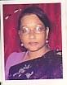 | DR. HOWA AKHTAR ZAHAN  F/Name:  M/Name:  BM & DC Reg. No:  NID:  Cell:  Address: Junior Consultant (Gynae) Sadar Hospital Barisal  Blood Group:
79 | Voter No  LM-0400079  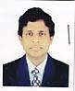 | DR. MAHBUBUR RAHMAN  F/Name:  M/Name:  BM & DC Reg. No:  NID:  Cell:  Address: Band Road Sagordi Barisal  Blood Group:
80 | Voter No  LM-0400080  No Image | DR. FARID AHMED  F/Name:  M/Name:  BM & DC Reg. No:  NID:  Cell:  Address: Radiologist General Hospital Barisal  Blood Group:
81 | Voter No  LM-0400081  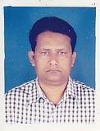 | DR. N.H. ANISULLAH  F/Name:  M/Name:  BM & DC Reg. No:  NID:  Cell:  Address: Sadar Hospital Barisal  Blood Group:
82 | Voter No  LM-0400082  No Image | DR. MD. KHAIRUL ALAM  F/Name:  M/Name:  BM & DC Reg. No:  NID:  Cell:  Address: Civil Surgeion, Barisal  Blood Group:
83 | Voter No  LM-0400083  No Image | DR. MUHAMMAD IZHARUL FAIZ KHAN  F/Name:  M/Name:  BM & DC Reg. No:  NID:  Cell:  Address: Medical Officer Civil Surgeon Office Barisal  Blood Group:
84 | Voter No  LM-0400084  No Image | DR. MOHD. HABIBUR RAHMAN  F/Name:  M/Name:  BM & DC Reg. No:  NID:  Cell:  Address: Vill-Kashipur, Barisal  Blood Group:
85 | Voter No  LM-0400085  No Image | DR. MD. YUNUS ALI MIA  F/Name:  M/Name:  BM & DC Reg. No:  NID:  Cell:  Address: Medical Officer TB & Leprosy Civil Surgeon Office, Barisal  Blood Group:
86 | Voter No  LM-0400086  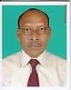 | DR. GORANGA LAL HOWLADER  F/Name:  M/Name:  BM & DC Reg. No:  NID:  Cell:  Address: Medical Officer Shaisthabad Sub-Center Barisal  Blood Group:
87 | Voter No  LM-0400087  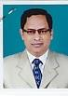 | DR. MD. TAIABUR RAHMAN  F/Name:  M/Name:  BM & DC Reg. No:  NID:  Cell:  Address: Medical Officer MD. M.C.H.F.P Sadar THC, Barisal  Blood Group:
88 | Voter No  LM-0400088  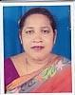 | DR. NOIMA KHAN  F/Name:  M/Name:  BM & DC Reg. No:  NID:  Cell:  Address: Vill-Sharisamur, Fuljuri Barisal  Blood Group:
89 | Voter No  LM-0400089  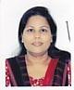 | DR. AFROZA BAHAR  F/Name:  M/Name:  BM & DC Reg. No:  NID:  Cell:  Address: Band Road Gagordi Barisal  Blood Group:
90 | Voter No  LM-0400090  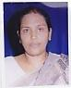 | DR. BAKUL BASAK  F/Name:  M/Name:  BM & DC Reg. No:  NID:  Cell:  Address: Asstt. Surgeon, FWVTI Kalibari Road Barisal  Blood Group:
91 | Voter No  LM-0400091  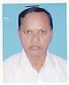 | DR. A.S.M. ABDUS SATTAR MIA  F/Name:  M/Name:  BM & DC Reg. No:  NID:  Cell:  Address: Medical Officer Madabpasa, Babugonj Barisal  Blood Group:
92 | Voter No  LM-0400092  No Image | DR. TANBIR AHMED SIKDER  F/Name:  M/Name:  BM & DC Reg. No:  NID:  Cell:  Address: Thana Health Complex Banaripara Barisal  Blood Group:
93 | Voter No  LM-0400093  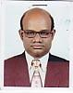 | DR. SWAPAN KUMAR MITRA  F/Name:  M/Name:  BM & DC Reg. No:  NID:  Cell:  Address: Thana Health Complex Banaripara Barisal  Blood Group:
94 | Voter No  LM-0400094  No Image | DR. MD. GOLAM SARWAR  F/Name:  M/Name:  BM & DC Reg. No:  NID:  Cell:  Address:  Blood Group:
95 | Voter No  LM-0400095  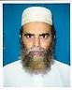 | DR. MD. MUSTAFIZUR RAHMAN  F/Name:  M/Name:  BM & DC Reg. No:  NID:  Cell:  Address: Gouranadi Bandar Barisal  Blood Group:
96 | Voter No  LM-0400096  No Image | DR. JATINDRA NATH PAUL  F/Name:  M/Name:  BM & DC Reg. No:  NID:  Cell:  Address:  Blood Group:  E X P I R E D
97 | Voter No  LM-0400097  No Image | DR. SHAMSUN NAHAR BEGUM  F/Name:  M/Name:  BM & DC Reg. No:  NID:  Cell:  Address: Subhan Mansion Alekanda Barisal  Blood Group:
98 | Voter No  LM-0400098  No Image | DR. FOUZIA RAHMAN  F/Name:  M/Name:  BM & DC Reg. No:  NID:  Cell:  Address: LATIFA MANZIL NEW HOUSE ROAD BARISAL  Blood Group:
99 | Voter No  LM-0400099  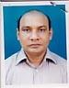 | DR. MASUD AHMAD  F/Name:  M/Name:  BM & DC Reg. No:  NID:  Cell:  Address: Arunima New Circular Road Barisal  Blood Group:
100 | Voter No  LM-0400100  No Image | DR. RAJIA BEGUM  F/Name:  M/Name:  BM & DC Reg. No:  NID:  Cell:  Address: 14, Parara Road Barisal  Blood Group:
101 | Voter No  LM-0400101  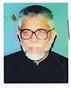 | DR. A.K.M. MOKHLESUR RAHMAN  F/Name:  M/Name:  BM & DC Reg. No:  NID:  Cell:  Address: 113, Sadar Road Barisal  Blood Group:
102 | Voter No  LM-0400102  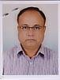 | DR. MD. MATIUR RAHMAN  F/Name:  M/Name:  BM & DC Reg. No:  NID:  Cell:  Address: H.O Barisal Pourashava 86, Sadar Road Barisal  Blood Group:
103 | Voter No  LM-0400103  No Image | DR. SAMIRAN CHAKRABARTY  F/Name:  M/Name:  BM & DC Reg. No:  NID:  Cell:  Address: 86, Sadar Road Barisal  Blood Group:
104 | Voter No  LM-0400104  No Image | DR. AKM. SHAHINUR RAHMAN  F/Name:  M/Name:  BM & DC Reg. No:  NID:  Cell:  Address: Rahman Pharmacy, Hospital Road Barisal  Blood Group:
105 | Voter No  LM-0400105  No Image | DR. NAZMA HUQ  F/Name:  M/Name:  BM & DC Reg. No:  NID:  Cell:  Address: Bazar Road, Barisal  Blood Group:
106 | Voter No  LM-0400106  No Image | DR. MD. JAHANGIR ALAM CHAKLADER  F/Name:  M/Name:  BM & DC Reg. No:  NID:  Cell:  Address: Bogra Road Barisal  Blood Group:
107 | Voter No  LM-0400107  No Image | DR. KISHORE KUMAR HALDER  F/Name:  M/Name:  BM & DC Reg. No:  NID:  Cell:  Address: Asstt. Prof. ENT.,  Noakhali Medical College  Noakhali,  Blood Group:  TRANSFERED to BMA Dhaka City  LM-1405543
108 | Voter No  LM-0400108  No Image | DR. SURAJIT KUMAR BAIN  F/Name:  M/Name:  BM & DC Reg. No:  NID:  Cell: 01712662799  Address: 53, TB. Boundary Road Khulna  Blood Group:  TRANSFERED to BMA Dhaka City  LM-1405543
109 | Voter No  LM-0400109  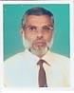 | DR. JAMAL UDDIN  F/Name:  M/Name:  BM & DC Reg. No:  NID:  Cell:  Address: Ahmed Villa Ahmed Muslim Gurostan Rd. Barisal  Blood Group:
110 | Voter No  LM-0400110  No Image | DR. SUDHENDO PROKAS BISWAS  F/Name:  M/Name:  BM & DC Reg. No:  NID:  Cell:  Address: Professor Of Microbiology Dibetic Association Medical College, Faridpur.  Blood Group:  TRANSFERED to BMA Dhaka City  LM-1405543
111 | Voter No  LM-0400111  No Image | DR. SHIPRA SINHA ROY  F/Name:  M/Name:  BM & DC Reg. No:  NID:  Cell:  Address: Professor Of Physiology Dibetic Association Medical College, Faridpur.  Blood Group:  TRANSFERED to BMA Dhaka City  LM-1405543
112 | Voter No  LM-0400112  No Image | DR. ABDUS SALAM KHAN  F/Name:  M/Name:  BM & DC Reg. No:  NID:  Cell:  Address:  Blood Group:  E X P I R E D
113 | Voter No  LM-0400113  No Image | DR. MD. SIDDIQUE HOSSAIN  F/Name:  M/Name:  BM & DC Reg. No:  NID:  Cell:  Address:  Blood Group:  TRANSFERED to BMA Dhaka City  LM-1405543
114 | Voter No  LM-0400114  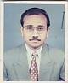 | DR. MD. ZAKIR HOSSAIN  F/Name:  M/Name:  BM & DC Reg. No:  NID:  Cell:  Address: Registrar, Cardiology Sher-E-Bangla Medical College Barisal  Blood Group:
115 | Voter No  LM-0400115 | DR. MD. HARUN-OR-RASHID  F/Name:  M/Name:  BM & DC Reg. No:  NID:  Cell:  Address: Ent. Department Sher-E-Bangla Medical College Barisal  Blood Group:
116 | Voter No  LM-0400116  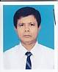 | DR. ABDUL MANNAN  F/Name:  M/Name:  BM & DC Reg. No:  NID:  Cell:  Address: Medical Officer Sher-E-Bangla Medical College Barisal  Blood Group:
117 | Voter No  LM-0400117  No Image | DR. MD. SIDDIQUR RAHMAN  F/Name:  M/Name:  BM & DC Reg. No:  NID:  Cell:  Address: Doctor's Cabin-2 Sher-E-Bangla Medical College Barisal  Blood Group:
118 | Voter No  LM-0400118  No Image | DR. MD. ANWAR HOSSAIN  F/Name:  M/Name:  BM & DC Reg. No:  NID:  Cell:  Address: Malek Mansion Sagordi, Barisal  Blood Group:
119 | Voter No  LM-0400119  No Image | DR. MOSAMMAT HASINA KHONDAKER  F/Name:  M/Name:  BM & DC Reg. No:  NID:  Cell:  Address: Medical Officer Fair Health Clinic Barisal  Blood Group:
120 | Voter No  LM-0400120  No Image | DR. MD. NAZRUL ISLAM  F/Name:  M/Name:  BM & DC Reg. No:  NID:  Cell:  Address: Medical Officer Fair Health Clinic Barisal  Blood Group:
121 | Voter No  LM-0400121  No Image | DR. SARMIN JAHAN  F/Name:  M/Name:  BM & DC Reg. No:  NID:  Cell:  Address: Medical Officer Eden Nursing Home Bagura Road, Barisal  Blood Group:
122 | Voter No  LM-0400122  No Image | DR. MRINAL KANTI MONDOL  F/Name:  M/Name:  BM & DC Reg. No:  NID:  Cell:  Address:  Blood Group:
123 | Voter No  LM-0400123  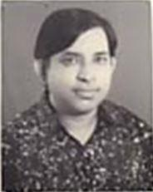 | DR. KAMAL KRISHNA KARMAKAR  F/Name: Sudhangshu Kumar Karmakar  M/Name:  BM & DC Reg. No: 16203  NID:  Cell:  Address: Sher-E-Bangla Medical College Barisal  Blood Group:
124 | Voter No  LM-0400124  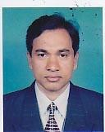 | DR. MD. ZAHURUL HOQ  F/Name:  M/Name:  BM & DC Reg. No:  NID:  Cell:  Address: Consultant, Sadar Hospital, Barisal  Blood Group:
125 | Voter No  LM-0400125  No Image | DR. SHANKAR KUMAR BISWAS  F/Name:  M/Name:  BM & DC Reg. No:  NID:  Cell:  Address: Medical Officer Nuclear Medical Centre Barisal  Blood Group:
126 | Voter No  LM-0400126  No Image | DR. BRINDABAN BISWAS  F/Name: Late Narayan Chandra Biswas  M/Name:  BM & DC Reg. No: 12930  NID:  Cell:  Address: Asstt. Professor, Blood Transfussion Department, Sher-E-Bangla Medical College, Barisal  Blood Group:
127 | Voter No  LM-0400127  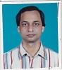 | DR. TARIT KUMAR SAMADDER  F/Name:  M/Name:  BM & DC Reg. No:  NID:  Cell:  Address: Asstt. Prof. Radiothe. Dept. Sher-E-Bangla Medical College Barisal  Blood Group:
128 | Voter No  LM-0400128  No Image | DR. K.B.M. ABDUR RAHMAN  F/Name:  M/Name:  BM & DC Reg. No:  NID:  Cell:  Address: Director Nuclear Medical Center Barisal  Blood Group:
129 | Voter No  LM-0400129  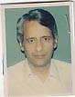 | DR. MD. SHAHIDUL ALAM  F/Name:  M/Name:  BM & DC Reg. No:  NID:  Cell:  Address: Associate Professor (Eye) Sher-E-Bangla Medical College Barisal  Blood Group:
130 | Voter No  LM-0400130  No Image | DR. A.S.M.KAMAL UDDIN  F/Name: Abu Motahar  M/Name:  BM & DC Reg. No: 7521  NID:  Cell:  Address: Associate Professor (Eye) Sher-E-Bangla Medical College Barisal  Blood Group:
131 | Voter No  LM-0400131  No Image | PROF. DR. MD. MONIRUL ISLAM  F/Name:  M/Name:  BM & DC Reg. No:  NID:  Cell:  Address: Mymenshing Medical College, Mymensingh  Blood Group:  TRANSFERED to BMA Dhaka City  LM-1405543
132 | Voter No  LM-0400132  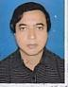 | DR. MD. ABDUR RAHIM  F/Name: Late Md. Akram Ali Sikder  M/Name: Late Mrs. Rahima Begum  BM & DC Reg. No: 14678  NID: 061948279741  Cell: 01716244677  Address: R. M. O. Upazilla Health Complex, Pirozpur  Blood Group: O+
133 | Voter No  LM-0400133  No Image | DR. A.M. FARIDUZZAMAN  F/Name:  M/Name:  BM & DC Reg. No:  NID:  Cell:  Address: Medical Officer, MCH & FP Banaripara, Barisal  Blood Group:
134 | Voter No  LM-0400134  No Image | DR. BIKASH MAJUMDER  F/Name:  M/Name:  BM & DC Reg. No:  NID:  Cell:  Address: Jahura Mansion 20/20, Gora Chand Das Road Barisal  Blood Group:
135 | Voter No  LM-0400135  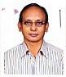 | DR. SHAH ALAM TALUKDER  F/Name:  M/Name:  BM & DC Reg. No:  NID:  Cell:  Address: Asstt. Professor Sher-E-Bangla Medical College Barisal  Blood Group:
136 | Voter No  LM-0400136  No Image | DR. MOHAMMAD NURUL ALAM  F/Name:  M/Name:  BM & DC Reg. No:  NID:  Cell:  Address: Asstt. Prof. Of Pediatric Surgery Sher-E-Bangla Medical College Barisal  Blood Group:
137 | Voter No  LM-0400137  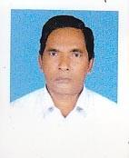 | DR. MD RAFIQUL ISLAM  F/Name:  M/Name:  BM & DC Reg. No:  NID:  Cell:  Address: ADCC, Dist. Family Planing Off. Barisal  Blood Group:
138 | Voter No  LM-0400138  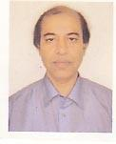 | DR. MIZANUR RAHMAN  F/Name:  M/Name:  BM & DC Reg. No:  NID:  Cell:  Address: RMO. General Hospital Barisal  Blood Group:
139 | Voter No  LM-0400139  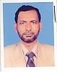 | DR. MD. HABIBUR RAHMAN  F/Name: Late Dalil Uddin  M/Name:  BM & DC Reg. No:  NID:  Cell:  Address: Asstt. Prof. Forensic Medicine SMCH Barisal  Blood Group:
140 | Voter No  LM-0400140  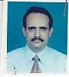 | DR. RANJIT CHANDRA KHAN  F/Name: Late Ranendra Chandra Khan  M/Name:  BM & DC Reg. No:  NID:  Cell:  Address: Asstt. Prof. SMCH Barisal  Blood Group:
141 | Voter No  LM-0400141  No Image | DR. KHONDOKER MD. HASSANUZZAMAN  F/Name: Khondoker Sohrab Hossain  M/Name:  BM & DC Reg. No:  NID:  Cell:  Address: Mitali C & B Road North Sagordi Barisal  Blood Group:
142 | Voter No  LM-0400142  No Image | DR. KABIRUZZAMAN  F/Name: Late Abdul Hakim Mridha  M/Name:  BM & DC Reg. No:  NID:  Cell:  Address: Asstt. Prof. Orthopaedic SMCH., Barisal.  Blood Group:
143 | Voter No  LM-0400143  No Image | DR. MD. SHOHEL MAHMUD  F/Name: Md. Helal Uddin Sikder  M/Name:  BM & DC Reg. No:  NID:  Cell:  Address: BCC-521 'Shapnil' West Kawnia Khanbari, Barisal.  Blood Group:
144 | Voter No  LM-0400144  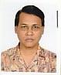 | DR. ASIT BHUSHAN DAS  F/Name: Krishna Lal Das  M/Name:  BM & DC Reg. No:  NID:  Cell:  Address: Asstt. Prof. Gastrointestin Al&Liver Disease SMCH., Barisal.  Blood Group:
145 | Voter No  LM-0400145 | DR. M. MUNIRUZZAMAN  F/Name: Late Md. Jaynal Abedin  M/Name:  BM & DC Reg. No:  NID:  Cell:  Address: Lecturer, Anatomy Department SMCH, Barisal  Blood Group:
146 | Voter No  LM-0400146  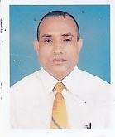 | DR. GAUR KISHORE CHAKRAVARTY  F/Name: Benoy Bhushon Chakravarty  M/Name:  BM & DC Reg. No:  NID:  Cell:  Address: Consultant Model Family Planing Clinic SMCH, Barisal  Blood Group:
147 | Voter No  LM-0400147  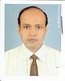 | DR. SYED MAKSUMUL HUQ  F/Name: Syed Nurul Huq  M/Name:  BM & DC Reg. No:  NID:  Cell:  Address: Radiologist, General Hospital Barisal  Blood Group:
148 | Voter No  LM-0400148  No Image | DR. FARUK ABDULLAH BIN ALAUDDIN  F/Name: Alhaj Alauddin Ahmed  M/Name:  BM & DC Reg. No:  NID:  Cell:  Address: Room No. 306, Intern Doctors Hostel Sher-E-Bangla Medical College Hospital Barisal.  Blood Group:
149 | Voter No  LM-0400149  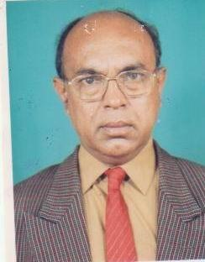 | DR. SAYED ZAHID HOSSAIN  F/Name: Late- Alhaj Sayed Belayet Hossain  M/Name:  BM & DC Reg. No:  NID:  Cell:  Address: Principal & Prof. Paediatrics, Sher-E-Bangla Medical College, Barisal.  Blood Group:
150 | Voter No  LM-0400150  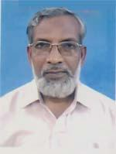 | DR. MOHAMMAD HUMAYUN KABIR  F/Name: Late Serajul Hoque  M/Name: Late Sirajun Nessa  BM & DC Reg. No: 9763  NID: 0695116219567  Cell: 01710965142  Address: Laty Mansion, Gorachand Das Road, Barisal  Blood Group: A+
151 | Voter No  LM-0400151  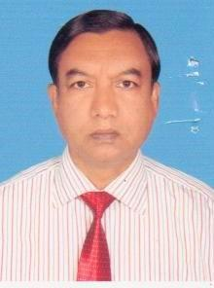 | DR. MD. ABDUL HAMID SHAIKH  F/Name: Late Shaizuddin Sk  M/Name: Amena Khatun  BM & DC Reg. No: 9799  NID:  Cell: 01711368058  Address: Assistant professor, Dept. of Paediatric, Sher e Bangla Medical College Barisal  Blood Group: B+
152 | Voter No  LM-0400152  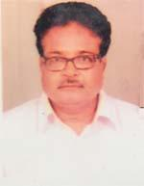 | DR. MD. ZOYBAL ABEDIN  F/Name: Md. Kashem Ali Mondol  M/Name: Mrs. Ayesha Khatun  BM & DC Reg. No: 17216  NID: 0695121253839  Cell: 01712530253  Address: Kheya College Avenue, Barisal  Blood Group: A+
153 | Voter No  LM-0400153  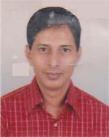 | S. M. SARWAR  F/Name: Mr. Ali Asgar  M/Name: Mrs. Azimunnesa  BM & DC Reg. No: 15939  NID: 0695114327097  Cell: 01711026357  Address: Professor ENT, South Apollo Medical College,Barishal  Blood Group: B+
154 | Voter No  LM-0400154  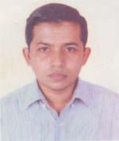 | DR. MD. FAIZUL BASHAR  F/Name: Md. Abul Bashir  M/Name: Fatema Khatun  BM & DC Reg. No: 23072  NID: 0695112193245  Cell: 01558326944  Address: Asst. Prof. Pathology Sher E Bangla Medical College, Barisal  Blood Group: B+
155 | Voter No  LM-0400155  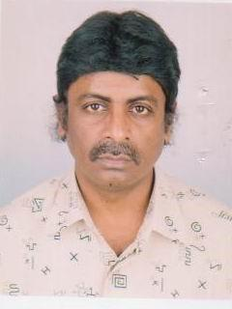 | DR. MD. BAKIR HOSSAIN  F/Name: Altaf Hossain Howlader  M/Name:  BM & DC Reg. No:  NID:  Cell:  Address: Genuine Furniture West Bogura Road Barisal.  Blood Group:
156 | Voter No  LM-0400156  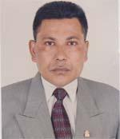 | DR. MD. DELWAR HOSSAIN  F/Name: Abdul Barek Mia  M/Name: Fatama Begum  BM & DC Reg. No: 15955  NID: 0695123267229  Cell: 01715005533  Address: Kerami Bari, Nabagram Road, Kotwali, Barisal  Blood Group: A+
157 | Voter No  LM-0400157  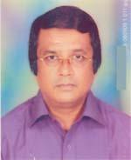 | DR. MD. RAISH UDDIN AHMED  F/Name: Late Md. A. Goni Mia  M/Name: Late Mrs. Fatema Begum  BM & DC Reg. No: 16895  NID: 0695115207264  Cell: 01914484871  Address: Sweet Home, Forester Bari Road, Barisal  Blood Group: O+
158 | Voter No  LM-0400158  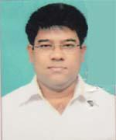 | DR. MD. MIZANUR RAHMAN  F/Name:  M/Name:  BM & DC Reg. No: 31909  NID:  Cell:  Address: VILL- SOUTH BIJOYPUR, P.O.: GOURNODI, P.S.: GOURNODI, DISTRICT: BARISAL.  Blood Group:  TRANSFERED to BMA Dhaka City  LM-1405543
159 | Voter No  LM-0400159  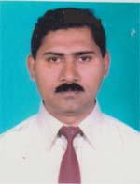 | DR. BHASKAR SAHA  F/Name: Late Balahari Saha  M/Name: Late Kamala Balahari Saha  BM & DC Reg. No: 14267  NID:  Cell: 01711388607  Address: Nazir Mahallah, Barisal  Blood Group: B+
160 | Voter No  LM-0400160  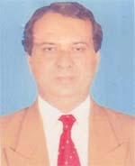 | DR. N. C. DEY ROBIN  F/Name: Late K. R. Dey  M/Name: Late Raujita Bala Dey  BM & DC Reg. No: 13953  NID: 0695116217344  Cell: 01711463190  Address: 151, N. Hossain Complex, Police Line Road, Barisal  Blood Group: A+
161 | Voter No  LM-0400161  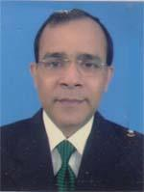 | DR. BIPLAB KUMAR DAS  F/Name: Sri Jamini Kanta Das  M/Name: Late Suniti Rani Das  BM & DC Reg. No: 16019  NID: 0695119234884  Cell: 01711190944  Address: Medical officer, Sher E Bangla Medical College, Hospital, Barisal  Blood Group: O+
162 | Voter No  LM-0400162  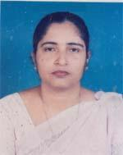 | DR. SHIKHA RANI SAHA  F/Name: Late Noni Gopal Saha  M/Name: Late Chinu Rani Saha  BM & DC Reg. No: 15581  NID: 0695112193218  Cell: 01716376060  Address: 6/D Doctors Quarter, Sher E Bangla Medical College, Barisal  Blood Group: A+
163 | Voter No  LM-0400163  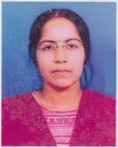 | DR. CHANDONA SORCAR  F/Name: Sankar Lal Sarker  M/Name: Minoti Ghosh  BM & DC Reg. No: 24358  NID: 695110181635  Cell: 01712951685  Address: Jabbar Miar Gali, Police Line, Barisal  Blood Group: A+
164 | Voter No  LM-0400164  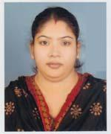 | DR. MALLIKA KARMAKER  F/Name: Ratnenwan Karmaker  M/Name: Monika Karmaker  BM & DC Reg. No: 32455  NID: 0695115211876  Cell: 01711281705  Address: Ark Villa (2nd Floor), Uhar Alekanda Road, Barisal  Blood Group: AB+
165 | Voter No  LM-0400165  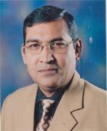 | DR. PRADIP KUMAR BANIK  F/Name: Tulshi Lal Banik  M/Name: Sabitri Banik  BM & DC Reg. No: 15021  NID: 0695104129789  Cell: 01711458083  Address: Medical officer, Medicine Out Door, Sher E Bangla Medical College Hospital, Barisal  Blood Group: B+
166 | Voter No  LM-0400166  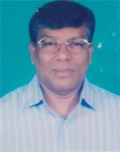 | DR. NITYA NANDA HALDER  F/Name: Late Jogendra Nath Halder  M/Name: Sona Laxmi Halder  BM & DC Reg. No: 14586  NID: 0695119239678  Cell: 01711169791  Address: Medical officer Eye Opd, Sher E Bangla Medical College Hospital, Barisal  Blood Group: A+
167 | Voter No  LM-0400167  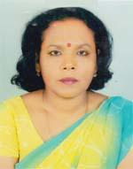 | DR. BANA LATA SINHA  F/Name: Late Moranjan Sinha  M/Name: Shre Moti Shati Lata Sinha  BM & DC Reg. No: 16081  NID: 0695118230764  Cell: 01914473661  Address: Lecturer of Biochemistry, SBMC, Barisal  Blood Group: B+
168 | Voter No  LM-0400168  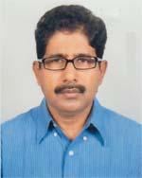 | ADHIR KUMAR DAS  F/Name: Dinabandhu Das  M/Name: Ashalata Dad  BM & DC Reg. No: 15758  NID: 0695118230765  Cell: 01914499317  Address: Pharmacology Department, Sher E Bangla Medical College, Barisal  Blood Group: O-
169 | Voter No  LM-0400169 | DR. BIDHAN CHANDRA BISWAS  F/Name: Nirad Baran Biswas  M/Name: Biva Rani Biswas  BM & DC Reg. No: 27062  NID: 2697557398060  Cell: 01556634030  Address: House of Nira Apa (2nd Floor), Oposit to The Senajia Primary School, Medical College Lane, South Alekanda, Barisal  Blood Group: A+
170 | Voter No  LM-0400170  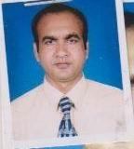 | DR. MD. MONIRUZZAMAN SHAHIN  F/Name:  M/Name:  BM & DC Reg. No:  NID:  Cell:  Address: Asstt. Prof. Of Ortho. Surgery, Sher-E-Bangla Medical College Hospital, Barisal.  Blood Group:
171 | Voter No  LM-0400171 | DR. MD. ANOWAR HOSSAIN HOWLADER  F/Name: Late Taher Ali Howlader  M/Name:  BM & DC Reg. No:  NID:  Cell:  Address: a  Blood Group:
172 | Voter No  LM-0400172  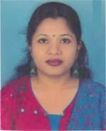 | DR. SHERIN SABIHA TONNY  F/Name: Md. Nurul Alam  M/Name: Mrs. Sherin Shamsunnahar  BM & DC Reg. No: 50437  NID: 0695115208955  Cell: 01811410795  Address: Swapna Sarga, forester Lean, New Circular Road, Barisal  Blood Group: O+
173 | Voter No  LM-0400173  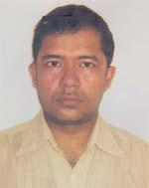 | DR. MD. MOKLESUR RAHMAN KHAN  F/Name: Khan Mosaraf Hossen  M/Name: Aopia Haque  BM & DC Reg. No: 49142  NID: 0619494204706  Cell: 01914850212  Address: Doctor Hostel SBMCH  Blood Group: B+
174 | Voter No  LM-0400174  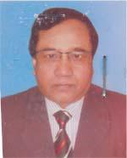 | DR. HORENDRA NATH SARKER  F/Name: Mongal Ch..Sarker  M/Name: Late Sarala Rani Sarker  BM & DC Reg. No: 16111  NID:  Cell: 01715079037  Address: Associate Professor, Medicine, Sbmc, Barisal.  Blood Group:
175 | Voter No  LM-0400175  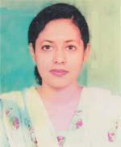 | DR. NAZIA SULTANA  F/Name: Md. Abdul Majid  M/Name: Most. Lutfunnesha  BM & DC Reg. No: 43041  NID: 0695120243114  Cell: 01712655103  Address: Mourakkei, New College Road, Barisal-8200, Bangladesh  Blood Group: A+
176 | Voter No  LM-0400176  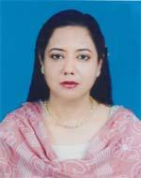 | DR. SYEEDA SULTANA (SWEETY)  F/Name: Md. Abdul Majid  M/Name: Most. Lutfunnesha  BM & DC Reg. No: 26610  NID: 0695114204683  Cell: 01711230450  Address: Sumayeeta C & B Road, Barisal -8200, Opposite Badc, Ward No. 14  Blood Group: A+
177 | Voter No  LM-0400177  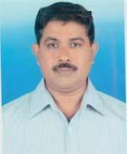 | DR. MD. SHAFIQUL ISLAM  F/Name: Late Dr. Md. Amirul Islam  M/Name: Most. Ayesha Begum  BM & DC Reg. No: 23259  NID: 0695114204702  Cell: 01715704337  Address: Sumayeeta C & B Road, Opposite Badc, Barisal-8200, Bangladesh  Blood Group: A+
178 | Voter No  LM-0400178  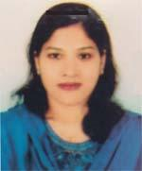 | DR. NAZNIN AKTER (RUBY)  F/Name: Md. Jahagir Kabir  M/Name: Mrs. Monowara Begum  BM & DC Reg. No: 29413  NID: 0695112194063  Cell: 01712552764  Address: Asst. Prof (paediatrics) SBMC, Barisal  Blood Group: O+
179 | Voter No  LM-0400179  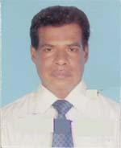 | DR. MD. FARUQUE ALAM  F/Name: Late Erajuddin Ahmed  M/Name: Ayesha Khatun  BM & DC Reg. No: 15658  NID: 0695124279288  Cell: 01712213033  Address: Lecturer , Microbiology Department, Sher e Bangla Medical College, Barisal  Blood Group: B+
180 | Voter No  LM-0400180  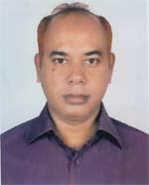 | DR. ABU HASSAN MD. RAFIQUL BARI  F/Name: Late Md. Haider Ali  M/Name: Late Rahima Khatun  BM & DC Reg. No: 23940  NID: 0695116219792  Cell: 01711961093  Address: Rabeya Manjil, 62/56, Gora Chand Das Road, Barisal-8200  Blood Group: O+
181 | Voter No  LM-0400181  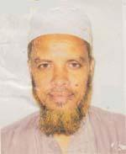 | DR. KHONDKER ABDUL MONEM  F/Name: Khondker Abdul Mabud  M/Name: Mahmuda Khatun  BM & DC Reg. No: 18393  NID: 0695115210422  Cell: 01711455621  Address: Hazrat Kalu Shah Road, Atekanda, Barisal-8200  Blood Group: B+
182 | Voter No  LM-0400182  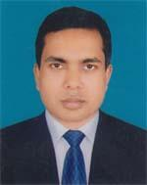 | DR. MD. ABU JAFAR  F/Name: Shams Uddin Ahamed  M/Name: Lutfa Ahamed  BM & DC Reg. No: 40312  NID: 0410987349996  Cell: 01714340413  Address: R. M. O. Advocate Hemayet Uddin, Diabetic Hospital, Barisal  Blood Group: O+
183 | Voter No  LM-0400183 | DR. MD. MASRAFUL ISLAM  F/Name: Dr. A. S. M. Abdus Sattar Mia  M/Name: Sayeda Begum  BM & DC Reg. No: 51557  NID: 0695101101507  Cell: 01558841610  Address: Nur Bhaban, Hagera, Khatun School Road, West Kawria, Ward No. 01, Barisa City  Blood Group: A+
184 | Voter No  LM-0400184 | DR. MD. SAIFUL ISLAM  F/Name: Abul Kalam Azad  M/Name: Hafiza Begum  BM & DC Reg. No: 43184  NID: 7813811988748  Cell: 01720494900  Address: Lecturer Microbiology, Sher E Bangla Medical College, Barisal  Blood Group: A+
185 | Voter No  LM-0400185  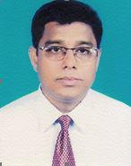 | DR. SHAFIKUL ISLAM KHAN  F/Name: Mansur Ahmed Khan  M/Name: Rahima Begum  BM & DC Reg. No: 22711  NID:  Cell: 01712163242  Address: : 03/E, Doctor’s Quarter, Sher-E-Bangla Medical College Hospital, Barisal.  Blood Group:
186 | Voter No  LM-0400186 | DR. SHAHIDA BEGUM  F/Name: Late. Delwar Hossain  M/Name: Hosne- Ara- Begum  BM & DC Reg. No: 25751  NID:  Cell:  Address: Ara Dela, Fakir Bari Road, Barisal.  Blood Group:
187 | Voter No  LM-0400187  No Image | DR. S.M. JALAL UDDIN  F/Name: Dr. S.M. Anisur Rahman  M/Name: Sayeda Farida Banu  BM & DC Reg. No:  NID:  Cell: 01717513831  Address: C/O, Dr. S.M. Anisur Rahman, Sayed Villa, Natun Bazar, Barisal.  Blood Group:
188 | Voter No  LM-0400188  No Image | DR. KAMALASHIS ROY  F/Name: Ramendra Narayan Roy  M/Name: Late. Lekha Roy  BM & DC Reg. No: 26686  NID:  Cell: 01711475959  Address: Dept. Of Ortho Surgery, Sbmch, Barisal.  Blood Group:
189 | Voter No  LM-0400189  No Image | DR. SHAIKH MOHAMMAD KAMAL HOSSAIN  F/Name:  M/Name:  BM & DC Reg. No: 26697  NID:  Cell: 01711298281  Address: 113, Interns Doctors Hostel, Sher-E- Bangla Medical College, Barisal.  Blood Group:  TRANSFERED to BMA Dhaka City  LM-1405543
190 | Voter No  LM-0400190  No Image | DR. SAURAV SUTAR  F/Name: Subhash Chandra Sutar  M/Name: Kamal Rani Mondal  BM & DC Reg. No: 39757  NID:  Cell: 01722717188  Address: Medical Officer, Surgery Unit-04, Sbmch, Barisal.  Blood Group:
191 | Voter No  LM-0400191  No Image | DR. GOBINDA LAL KUNDU  F/Name: Haripada Kundu  M/Name: Usha Rani Kundu  BM & DC Reg. No: 22131  NID:  Cell: 01711204317  Address: Medical Officer, (Mch-Fp), Barisal Sadar, Barisal.  Blood Group:
192 | Voter No  LM-0400192  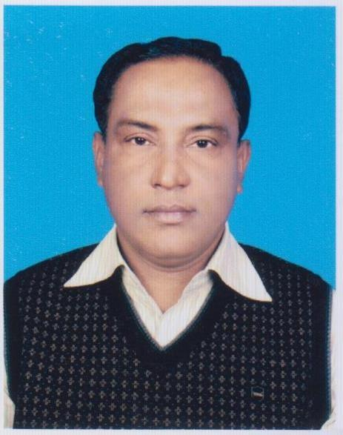 | DR. A. J. M. EMRUL KAYESH  F/Name: Late Abdul Karim  M/Name: Late Mrs. Achia Karim  BM & DC Reg. No: 21881  NID:  Cell: 01712561504  Address: Medical Officer, MFP Clinic, Sher-E- Bangla Medical College Hospital, Barisal.  Blood Group:
193 | Voter No  LM-0400193  No Image | DR. NASREEN SULTANA  F/Name: Md. Zahangir Kabir  M/Name: Mrs. Monwara Kabir  BM & DC Reg. No: 21934  NID:  Cell: 01711186359  Address: Mowbon Palace, Bangla Bazar, Barisal.  Blood Group:
194 | Voter No  LM-0400194  No Image | DR. MD. HABIBUR RAHMAN  F/Name: Late. Kashem Ali Howlader  M/Name: Late. Bakphul Begum  BM & DC Reg. No: 22391  NID:  Cell: 01718924639  Address: Mowbon Palace, Bangla Bazar, Alekanda, Barisal.  Blood Group:
195 | Voter No  LM-0400195  No Image | DR. SHUKHA RANJAN DAS  F/Name:  M/Name:  BM & DC Reg. No: 51492  NID:  Cell: 01712356938  Address: 61, KandaPara, Narsingdi.  Blood Group:  TRANSFERED to BMA Dhaka City  LM-1405543
196 | Voter No  LM-0400196  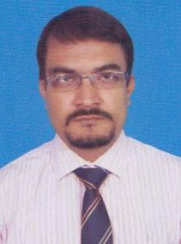 | DR. ALA UDDIN  F/Name: Joynul Abedin  M/Name: Jebun Nesa Begum  BM & DC Reg. No:  NID:  Cell: 01819128801  Address: Sher-E-Bangla Medical College Hospital,Barisal Sadar, Barisal-8200  Blood Group:
197 | Voter No  LM-0400197  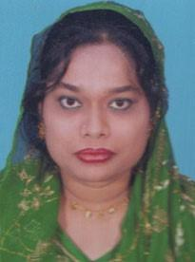 | DR. RAKSANA NASIMA AKTER  F/Name: Amir Hossain  M/Name: Zohora Begum  BM & DC Reg. No: 34866  NID:  Cell: 01816433528  Address: Sher-E-Bangla Medical College Hosptial, Sadar, Barisal  Blood Group:
198 | Voter No  LM-0400198  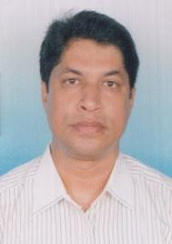 | DR. AMITABH SARKER  F/Name: Nepal Chandra Sarker  M/Name: Late Bela Rani Sarkar  BM & DC Reg. No: 26759  NID:  Cell: 01712244854  Address: Registrar (Neuro Medicine) Sher-E-Bangla Medical College Hospital, Barisal  Blood Group:
199 | Voter No  LM-0400199  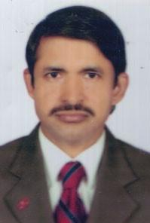 | DR. BIKASH CHANDRA NAG  F/Name: Lakshman Chandra Nag  M/Name: Promila Nag  BM & DC Reg. No:  NID:  Cell: 01716311601  Address: Department Of Paediatrics, Asstt. Prof. Sher-E-Bangla Medical College Hospital, Barisal  Blood Group:
200 | Voter No  LM-0400200  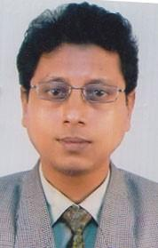 | DR. MD. MIZANUR RAHMAN  F/Name: Abdul Khaleque Mia  M/Name: Monoara Begum  BM & DC Reg. No: 22513  NID:  Cell: 01712901421  Address:  Blood Group:
201 | Voter No  LM-0400201  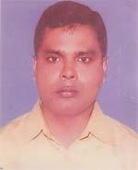 | DR. SMARAJIT KUMAR MONDAL  F/Name: Dwijendronath Mondal  M/Name: Radha Rani Mondal  BM & DC Reg. No: 29378  NID: 19722691650000027  Cell: 01712506794  Address: 3/C Doctor Quater, Shear E Bangla Medical College  Blood Group: A+
202 | Voter No  LM-0400202  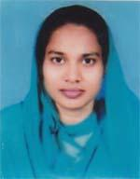 | DR. MOST. NASRIN JAHAN  F/Name: Azm. Ismail Hossain  M/Name: Rawson Ara Begum  BM & DC Reg. No: 30443  NID: 197878295081644  Cell: 01711462479  Address: Lecturer Pathology , Sbmc, Barisal  Blood Group: O+
203 | Voter No  LM-0400203  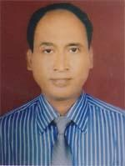 | DR. GM. NAZIMUL HAQUE  F/Name: Late Md. Durlove Gazi  M/Name: Most. Saleha Begum  BM & DC Reg. No: 24944  NID: 7829508132645  Cell: 01724210773  Address: Assistant Prof. Surgery Department SBMC, Barisal  Blood Group: A+
204 | Voter No  LM-0400204  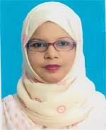 | DR. MOSAMMAT SHAHNAZ PERVIN  F/Name: Md. Abul Kalam Howlader  M/Name: Shahenur Begum  BM & DC Reg. No: 39618  NID: 0695113197701  Cell: 01815971696  Address: Book Villa Goli, Behind The Nooria School. Dakshin Alekanda, Barisal  Blood Group: AB+
205 | Voter No  LM-0400205  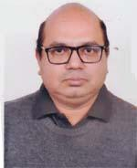 | DR. TOWHIDUL ISLAM  F/Name: Md. Zaynul Abedin  M/Name: Mrs. Hasina Taj  BM & DC Reg. No: 24008  NID: 19680695112194060  Cell: 01715576009  Address: 8/A Doctor Quarter, SBMC, Barisal  Blood Group: A+
206 | Voter No  LM-0400206  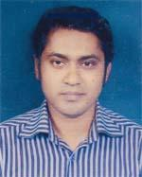 | DR. SALAH AL DIN BIN NASIR  F/Name: Md. Nasir Uddin Molla  M/Name: Mrs. Firoja Begum  BM & DC Reg. No: 41336  NID: 2696405643418  Cell: 01717437885  Address: Anju Neer, 2nd floor, Behind Govt. Barisal College  Blood Group: A+
207 | Voter No  LM-0400207 | DR. SHAH MD. FAZLAR RAHAMAN KHAN  F/Name: Dr. Shah Md. Fazlay Rahaman Khan  M/Name: Mahmuda Begum  BM & DC Reg. No: 39617  NID: 0695113197700  Cell: 01815971697  Address: Book Villa Goli, Behind the Nooria School, Dakshin Alekanda, Barisal  Blood Group: B+
208 | Voter No  LM-0400208  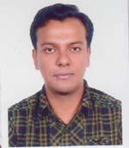 | DR. YASSEER HASSAN  F/Name: Dr. Md. Kamrul Hassan  M/Name: Dr. Syeda Hosne Ara  BM & DC Reg. No: 57670  NID: 19862692619597846  Cell: 01717054643  Address: I/D, Doctors Quater, SBMC, Barisal  Blood Group: A+
209 | Voter No  LM-0400209  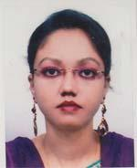 | DR. SADIA TASNIM  F/Name: Mohammad Abdul Hye  M/Name: Ismat Ara Begum  BM & DC Reg. No: 53804  NID: 2694811020350  Cell: 01715019539  Address: I/D, Doctors Qrt. , SBMC, Barisal  Blood Group: O+
210 | Voter No  LM-0400210  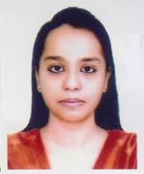 | DR. TASMIA HASSAN  F/Name: Dr. Md. Kamrul Hassan  M/Name: Dr. Syeda Hosne Ara  BM & DC Reg. No: 78322  NID: 19910695112000032  Cell: 01726393837  Address: 1/D, Doctors Qrt, SBMC, Barisal  Blood Group: A+
211 | Voter No  LM-0400211  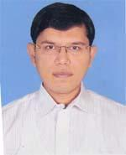 | DR. MD. NURUNNABI TUHIN  F/Name: Md. Abdul Quddus  M/Name: Nurunnaher Begum  BM & DC Reg. No: 47437  NID: 0695123264012  Cell: 01816492635  Address: Samsunnaher Monjil, Dorgah Bari Road, South Sagordi, Barisal  Blood Group: A+
212 | Voter No  LM-0400212 | DR. MD. REZWAN KAISER  F/Name: Md. Akhter Kamal  M/Name: Sultana Kamal  BM & DC Reg. No: 56568  NID: 0695116214772  Cell: 01744527172  Address: House-1076, East Amir Kutir, Barisal City Corporation, Barisal  Blood Group: O+
213 | Voter No  LM-0400213  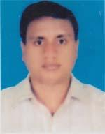 | DR. MD.MORSHEDUR RAHMAN  F/Name: Late Md. Abdur Rahman Khan  M/Name: Mrs. Morsheda Begum  BM & DC Reg. No: 38613  NID: 2697557395508  Cell: 01712558719  Address: Khan Monzil, New Circular Road, Barisal Sadar, Barisal  Blood Group: O+
214 | Voter No  LM-0400214 | DR. MD. MAHABUB ALAM  F/Name: Late Shamsul Alam Sardar  M/Name: Sultana Rajia  BM & DC Reg. No: 53927  NID: 19862697556419161  Cell: 01716586399  Address: Assistant Registar, Dept. SBMCH, Barisal  Blood Group: AB+
215 | Voter No  LM-0400215 | DR. SADIA AFRIN  F/Name: Sakhterul Alam  M/Name: Kamrunnahar  BM & DC Reg. No: 71763  NID: 19910695120000035  Cell: 01739909853  Address: Modhu Miah Bari, Modhu Miar Pools BM College Road, Barisal  Blood Group: A+
216 | Voter No  LM-0400216 | DR. MD. ZAHIRUL ISLAM  F/Name: Md. Hemayet Uddin  M/Name: Jebunnesa Begum  BM & DC Reg. No: 59283  NID: 0695111184750  Cell: 01713076326  Address: Vill & Post-Karnakati, Chgrkawa, Barisal Sadar  Blood Group: B+
217 | Voter No  LM-0400217  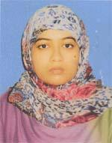 | DR. SATMA SADIA  F/Name: Md. Shahidullah  M/Name: Sharmin Akter  BM & DC Reg. No: 59298  NID: 0695118229062  Cell: 01675288932  Address: Upozilla Health Complex, Muladi, Barisal  Blood Group: O+
218 | Voter No  LM-0400218 | DR. MOSTOFA KAMAL  F/Name: Md. Dalil Uddin  M/Name: Mahfuza Begum  BM & DC Reg. No: 59282  NID: 0695114206606  Cell: 01675288931  Address: Upazilla Health Complex, Muladi, Barisal  Blood Group: B+
219 | Voter No  LM-0400219  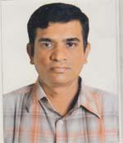 | DR. SUBRATA ROY  F/Name: Harabilash Roy  M/Name: Nandita Roy  BM & DC Reg. No: 25925  NID: 0695107153973  Cell: 01716881806  Address: Akashlina 2nd Floor, Sreenath Chatterjee Lane, Bagura Road , Barisal  Blood Group: AB+
220 | Voter No  LM-0400220  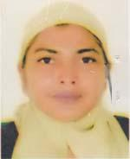 | DR. FARIDA BEGUM  F/Name: Late Mir Abul Kashem  M/Name: Late Mrs. Asia Begum  BM & DC Reg. No: 17147  NID: 0695119232356  Cell: 01712184259  Address: General Hospital Barisal  Blood Group: O+
221 | Voter No  LM-0400221  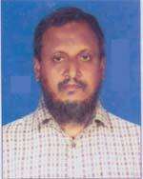 | DR. A. T. M. MOSTAFIZUR RAHMAN  F/Name: Late Md. Baktiar Hossain  M/Name: Jahanara Hossain  BM & DC Reg. No: 15942  NID: 19630695119000003  Cell: 01714008311  Address: General Hospital , Barisal  Blood Group: B+
222 | Voter No  LM-0400222  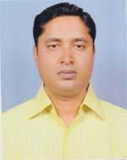 | DR. MOHAMMAD SHAHADAT HOSHEN  F/Name: Mohammad Hannan Mia  M/Name: Most. Rubia Begum  BM & DC Reg. No: 37784  NID: 5418095406102  Cell: 01712008312  Address: Nibir Palace (3rd Floor) , Shree nath Chattergy Dash Len, Bogra Road, Barisal  Blood Group: O+
223 | Voter No  LM-0400223  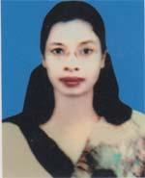 | DR. REHANA FERDOESH  F/Name: Muhammad Ali Mea  M/Name: Jahanara Ahshan  BM & DC Reg. No: 33280  NID: 0695113196295  Cell: 01712748695  Address: UHC, Agyljhara, Barisal  Blood Group: A+
224 | Voter No  LM-0400224  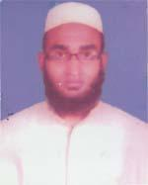 | DR. K. M. SAKIB  F/Name: Md. Shahidur Rahman  M/Name: Taslima Begum  BM & DC Reg. No: 61267  NID: 0695111185418  Cell: 01733405160  Address: UHC, Agailjhara, Barisal  Blood Group: A+
225 | Voter No  LM-0400225  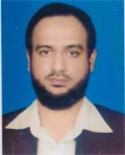 | DR. MD. ABDULLAH AL MAMUN  F/Name: Abdur Rashid Sarder  M/Name: Marium Begum  BM & DC Reg. No: 45104  NID: 19820616983000020  Cell: 01718114569  Address: Upazilla Health Complex, Agailjhara, Barisal  Blood Group: B+
226 | Voter No  LM-0400226  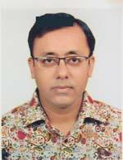 | DR. MD. BAKTHEIR AL MAMUN  F/Name: Md. Mohsin Baktheir  M/Name: Saleha Begum  BM & DC Reg. No: 62314  NID: 0695111185346  Cell: 01710697995  Address: Upazilla Health Complex, Agailjhara, Barisal  Blood Group: O+
227 | Voter No  LM-0400227  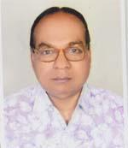 | DR. HIRAN MAY HALDET  F/Name: Bidin Behari Halder  M/Name: Kamol Kamini Halder  BM & DC Reg. No: 8698  NID: 0623207421193  Cell: n/A  Address: W. Sujankathi, Post-Agailjhara, Upazilla-Agailjhara, Dist-Barisal  Blood Group: O+
228 | Voter No  LM-0400228  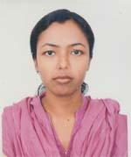 | DR. SHARMIN SULTANA  F/Name: Md. Abdur Razzaque  M/Name: Fatema Razzaque  BM & DC Reg. No: 54322  NID: 19850695112194150  Cell: 01672087475  Address: Agailjhara Upazilla Health Complex, Barisal  Blood Group: AB+
229 | Voter No  LM-0400229  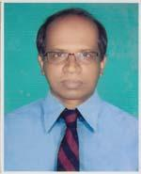 | DR. ASHIM RANJAN HALDER  F/Name: Amulya Kumar Halder  M/Name: Saraju Rani Halder  BM & DC Reg. No: 20847  NID: 0610215582275  Cell: 01715251276  Address: Upazilla Health Complex , Agailjhara, Barisal  Blood Group: A+
230 | Voter No  LM-0400230  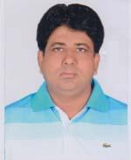 | DR. REZAUR RAHMAN  F/Name: Abdul Latif Mia  M/Name: Rawshan Ara  BM & DC Reg. No: 45211  NID: 2695434994449  Cell: 01711956740  Address: Milan Kutir, Sher E Bangla , Road, Rupatali, post-Rupatali Housing Estate, Rupatali, Barisal  Blood Group: O+
231 | Voter No  LM-0400231  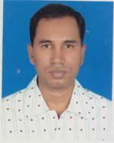 | DR. MD. WAHIDUZZAMAN  F/Name: Md. Abul Kalam  M/Name: Mrs. Saleha Begum  BM & DC Reg. No: 33432  NID: 7819561152245  Cell: 01718215742  Address: Medical officer, Sher E Bangla Medical College Hospital, Barisal  Blood Group: B+
232 | Voter No  LM-0400232  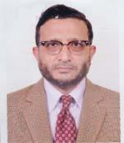 | DR. MD. SIDDIQUR RAHMAN  F/Name: Late A. K. M. Latifur Rahman  M/Name: Late Mrs. Sakuna Begum  BM & DC Reg. No: 14485  NID: 5425404141702  Cell: 01722618709  Address: Associate Prof. Sher E Bangla Medical College , Barisal  Blood Group: O+
233 | Voter No  LM-0400233  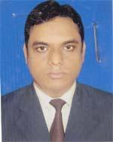 | DR. MD. ABUAL HASAN  F/Name: Late Md. Mokammel Hossen  M/Name: Badrun Nahar  BM & DC Reg. No: 41266  NID: 4218427462710  Cell: 01716507702  Address: Gaudia Lodge (Ground Floor), College Avenue (East End), Barisal  Blood Group: O+
234 | Voter No  LM-0400234 | DR. HARENDRA NATH SARKER  F/Name: Mongal Ch. Sarker  M/Name: Late Darala Rani Sarker  BM & DC Reg. No: 16111  NID:  Cell: 01715079037  Address: Associate Professor, Medicine SBMC, Barisal  Blood Group: B+
235 | Voter No  LM-0400235  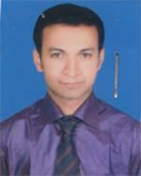 | DR. SUBRATA PAUL  F/Name: Jitendra Nath Paul  M/Name: Niva Rani Paul  BM & DC Reg. No: 51200  NID: 0695111189822  Cell: 01717808030  Address: SBMCH, Barisal  Blood Group: A+
236 | Voter No  LM-0400236 | DR. MD. RAKIB RAHMAN  F/Name: Md. Khalilur Rahman  M/Name: Monoara Begum  BM & DC Reg. No: 55044  NID: 0695115212326  Cell: 01675206364  Address: Ashraf Sharak, Nabagram Road, Barisal  Blood Group: B+
237 | Voter No  LM-0400237  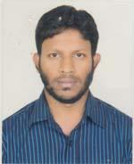 | DR. H. M. MASUM BILLAH  F/Name: Md. Hashan Master  M/Name: Rizia Khatun  BM & DC Reg. No: 48212  NID: 2694266786345  Cell: 01915453702  Address: A/R, Medical Unit, SBMCH, Barisal  Blood Group: O+
238 | Voter No  LM-0400238  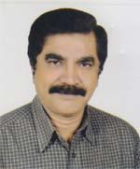 | DR. RABIN GHOSH  F/Name: Madhu Sudan Ghosh  M/Name: Maya Rani Ghosh  BM & DC Reg. No: 9304  NID: 0695117224199  Cell: 01715029312  Address: Anami Lane, Sadar Road, Barisal  Blood Group: B+
239 | Voter No  LM-0400239  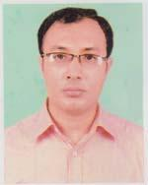 | DR. SHIMUL CHANDRA DAS  F/Name: Gouranga Chandra Das  M/Name: Maya Rani Das  BM & DC Reg. No: 67414  NID: 0613255441887  Cell: 01727195198  Address: Upazilla Health Complex, Agailjhara, Barisal  Blood Group: B-
240 | Voter No  LM-0400240  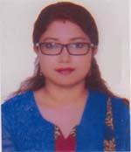 | DR. MOUSUMI MONDAL  F/Name: Bhisma Dev Mondal  M/Name: Chhanda Mondal  BM & DC Reg. No: 70966  NID: 19900695121000102  Cell: 01715855055  Address: 268, Jafarabad , Shankar, West Dhanmondi, Dhaka  Blood Group: O+
241 | Voter No  LM-0400241  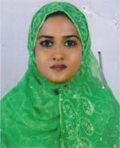 | DR. MUNZIBA SHIRIN  F/Name: Late Md. Abdul Mannan  M/Name: Zakia Begum  BM & DC Reg. No: 62224  NID: 19880695102115902  Cell: 01779942530  Address: Rakudia Lodge, Tarini Kumar Road, Kawnia, Barisal  Blood Group: B-
242 | Voter No  LM-0400242 | DR. MD. MUJIBUR RAHMAN TALUKDER  F/Name: Late Kadam Ali Talukder  M/Name: Late Hametunnesa  BM & DC Reg. No: 18451  NID: 19640695112194059  Cell: 01711114978  Address: Asso. Prof. Sher E Bangla Medical College, Barisal  Blood Group: A+
243 | Voter No  LM-0400243  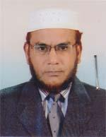 | PROF. DR. S. M. NAZRUL ISLAM  F/Name: A. Gafur  M/Name: Saleha Begum  BM & DC Reg. No: 15320  NID: 7343768698  Cell: 01711970281  Address: Department of Surgery, South Apollo Medical College, Barishal.  Blood Group: B+
244 | Voter No  LM-0400244  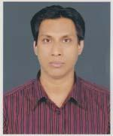 | DR. MD. SHAFIQUL ISLAM  F/Name: Md. Solaiman  M/Name: Mrs. Shamsun Nahar  BM & DC Reg. No: 27640  NID: 0695120247005  Cell: 01711579701  Address: Nilachol, Brown Compound, Barisal  Blood Group: AB+
245 | Voter No  LM-0400245  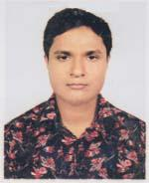 | DR. A. S. M. SAYEM  F/Name: Md. Habibullah  M/Name: Mrs. Kulsum Begum  BM & DC Reg. No: 57855  NID: 7823808027274  Cell: 01711871095  Address: SBMCH, Barisal  Blood Group: O+
246 | Voter No  LM-0400246 | DR. MD. AFJAL HOSSAIN  F/Name: Md. Salim Akon  M/Name: Miuara Begum  BM & DC Reg. No: 56520  NID: 19856125217227092  Cell: 01717337717  Address: Upazilla Health Complex, Baupual, Patuakhali  Blood Group: O+
247 | Voter No  LM-0400247  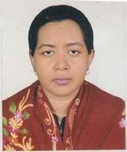 | DR. KANIZ FATEMA  F/Name: Md. Forhad Hossain Khan  M/Name: Mrs. Sajeda Begum  BM & DC Reg. No: 40054  NID: 19780695118226626  Cell: 01725379754  Address: Nilachol, Brown Compound, Barisal  Blood Group: AB+
248 | Voter No  LM-0400248  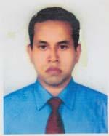 | DR. A. K. M. AKBAR KABIR  F/Name: Late Md. Atahar Ali Howlader  M/Name: Late Most. Kulsum Begum  BM & DC Reg. No: 44750  NID: 2697557395782  Cell: 01712055031  Address: Pantho Neer, Akkel Ali Road, Rupatoli, Post-Rupatoli Housing Estate, Sadar, Barisal  Blood Group: AB+
249 | Voter No  LM-0400249  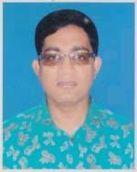 | DR. MD. SHAHIDUL ISLAM  F/Name: Md. Munsur Ali Howlader  M/Name: Mrs. Anwara Begum  BM & DC Reg. No: 39683  NID: 0695118230728  Cell: 01711386202  Address: Gorachad Das Road, Barisal  Blood Group: AB+
250 | Voter No  LM-0400250  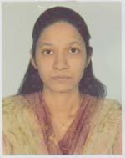 | DR. SUPRIYA KARMAKAR  F/Name: Sudhir Karmakar  M/Name: Panna Karmakar  BM & DC Reg. No: 53906  NID: 0695112194149  Cell: 01558887862  Address: Surgery Unit-2, SBMCH, Barisal  Blood Group: A+
251 | Voter No  LM-0400251  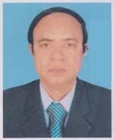 | DR. SAMORENDRA SARKER  F/Name: Late Monoranjan Sarker  M/Name: Monika Rani Sarker  BM & DC Reg. No: 22202  NID: 0695112193394  Cell: 01711124187  Address: 5/D Doctors Quarter, Sagardi, Barisal  Blood Group: O+
252 | Voter No  LM-0400252  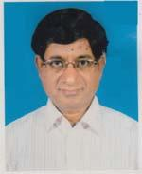 | DR. TAPAN KUMAR SAHA  F/Name: Late Sitanath Saha  M/Name: Late Soudamini Saha  BM & DC Reg. No: 16112  NID: 0695108162196  Cell: 01712625456  Address: Sristi, Hospital road, Barisal  Blood Group: B+
253 | Voter No  LM-0400253  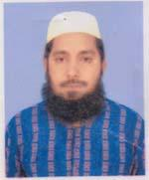 | DR. MASUM AHMED  F/Name: Mahbul Ahmed  M/Name: Fazilatunnessa  BM & DC Reg. No: 30091  NID: 19732693622294406  Cell: 01712031651  Address: 4/C, Doctors Quater, Sher-E-Bangla Medical College, Barisal  Blood Group:
254 | Voter No  LM-0400254  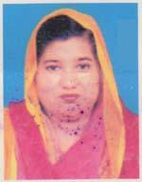 | DR. MAKSUDA ARJUMAND BANU  F/Name: Late Md. Adom Ali  M/Name: Mrs. Laila Ali  BM & DC Reg. No: 25335  NID: 0695112193308  Cell: 01712924266  Address: 822, Khirod Mukhevjee Lane, Bot Tola, Dist-Barisal  Blood Group: A+
255 | Voter No  LM-0400255 | DR. MD. MOMEN MOLLAH  F/Name: Md. Musleh Uddin Mollah  M/Name: Mrs. Jahanara Begum  BM & DC Reg. No: 56872  NID: 6125217227044  Cell: 01716614722  Address: Doctors Quarter, UHC, Bauphal, Bauphal, Patuahali  Blood Group: B+
256 | Voter No  LM-0400256  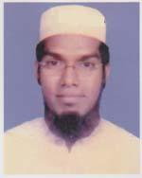 | DR. MOHAMMAD ABDUR ROUF  F/Name: Md. Momin Uddin Gazi  M/Name: Rebeka Khatun  BM & DC Reg. No: 37497  NID: 7823807037308  Cell: 01711113999  Address: UHC, Bauphal, Doctors Quarter, Bauphal, Patuakhali  Blood Group: A+
257 | Voter No  LM-0400257  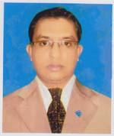 | DR. MD. SHIFUL ISLAM  F/Name: Md. Lutfor Rahman  M/Name: Mrs. Rowshan Ara  BM & DC Reg. No: 44637  NID: 19812619676119713  Cell: 01754545043  Address: Doctors Quarter, Upazilla Health Complex, Bauphal, Patuakhali  Blood Group: O+
258 | Voter No  LM-0400258  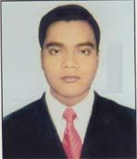 | DR. MUHAMMAD AKHTER UZ ZAMAN FAKIR  F/Name: Muhammad Abdur Rashid Fakir  M/Name: Mrs. Mahmuda Begum  BM & DC Reg. No: 52096  NID: 19830695111184867  Cell: 01712993580  Address: Upazilla Health Complex, Bauphal, Patuakhali  Blood Group: O+
259 | Voter No  LM-0400259 | DR. MD. AMINUL ISLAM  F/Name: Abdul Jalil Khan  M/Name: Amian Begum  BM & DC Reg. No: 61383  NID: 2716469409544  Cell: 01717729603  Address: Doctors Quarter, UHC, Dashmina, Patuakhali  Blood Group: O+
260 | Voter No  LM-0400260  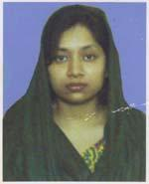 | DR. SHARMIN NAHAR  F/Name: Shahidul Islam  M/Name: Jasmin Akter  BM & DC Reg. No: 81059  NID: 19902726402000054  Cell: 01750960984  Address: Shaheda Gafur General Hospital, Kalaiya Bauphal, Patuakhali  Blood Group: B+
261 | Voter No  LM-0400261  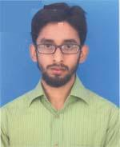 | DR. ABDULLAH AL SHAUROV  F/Name: Late Sekander Mia  M/Name: Fajilatunnesa  BM & DC Reg. No: 62751  NID: 7813877925955  Cell: 01716662358  Address: Shahi Mosjid Road, Bauphal, Patuakhali  Blood Group: AB+
262 | Voter No  LM-0400262  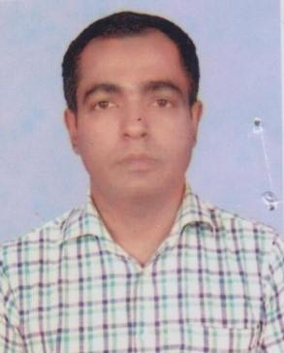 | DR. FAIZUL HAQUE PONIR  F/Name: Md. Fazlul Haque  M/Name: Mrs. Hasina Haque  BM & DC Reg. No: 36893  NID: 0695111184891  Cell: 01913921087  Address: RP. Paediatrics, SBMCH, Barisal.  Blood Group: B+
263 | Voter No  LM-0400263  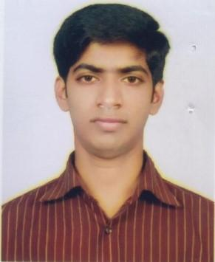 | DR. SOVAN BARAI  F/Name: Biswajit Barai  M/Name: Namita Rani  BM & DC Reg. No: 60618  NID: 824-376-8549  Cell: 01717952291  Address: Chandrahar, Batajone, Gournadi, Barisal, Lecturer, Microbiology, SBMC, Barisal.  Blood Group: B+
264 | Voter No  LM-0400264  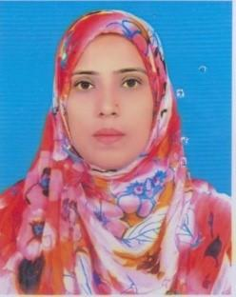 | DR. LUCKY PARVIN  F/Name: Abdur Rashid Sardar  M/Name: Samsur Naher  BM & DC Reg. No: 47832  NID: 4794512153445  Cell: 01718324061  Address: Somorto Nibash, Lutfor Rahman Road, Nathullahbad, Barisal.  Blood Group: O+
265 | Voter No  LM-0400265  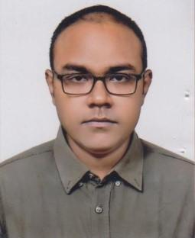 | DR. HAFIZ AHMED FAIAZ  F/Name: Mohammad Zahangir Hussain  M/Name: Nurun Nahar  BM & DC Reg. No: 68099  NID: 19890695120000001  Cell: 01703976192  Address: 125, College Avenue, Barisal.  Blood Group: A+
266 | Voter No  LM-0400266  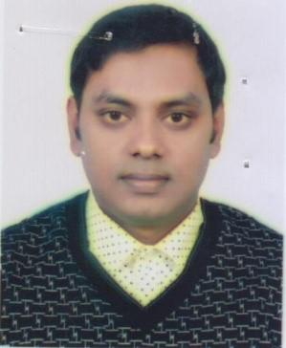 | DR. MD. MONIR HOSSAIN SAZIB  F/Name: Md. Golam Mostafa Salim  M/Name: Sakirun Nesa  BM & DC Reg. No: 81556  NID: 19900695124000029  Cell: 01672868646  Address: Khalifa Bari, Zia Nagor Rupatali, 24 No. Ward, BCC Barisal.  Blood Group: AB+
267 | Voter No  LM-0400267  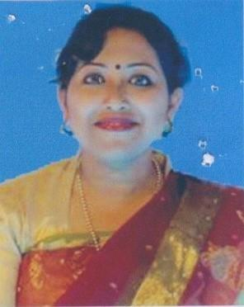 | DR. SANJIDA SHAHID  F/Name: Late Md. Shahidul Haq  M/Name: Semu Shahid  BM & DC Reg. No: 61501  NID: 19860695112194848  Cell: 01722203850  Address: Lecturer, Physiology, Sher-e Bangla Medical college, Barisal.  Blood Group: B+
268 | Voter No  LM-0400268  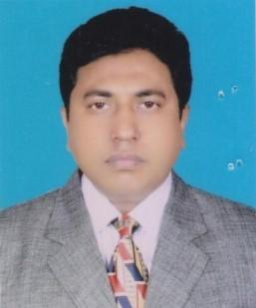 | DR. H.M. SAIFUL ISLAM  F/Name: Md. Moslem Ali Hawlader  M/Name: Khairun Nesa Begum  BM & DC Reg. No: 23931  NID: 0695108161408  Cell: 01718766025  Address: Lina Kunzo, C & B 1 Nong Pool, Barisal.  Blood Group: B+
269 | Voter No  LM-0400269  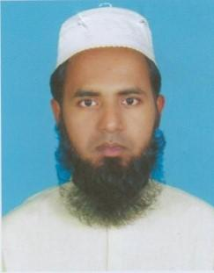 | DR. MD. AMINUL HAQUE  F/Name: Md. Bazlur Rashid Mullick  M/Name: Gulzar Begum  BM & DC Reg. No: 47264  NID: 19820695111185400  Cell: 01728368373  Address: 4C Doctors Quartar, SBMCH, Barisal.  Blood Group: O+
270 | Voter No  LM-0400270  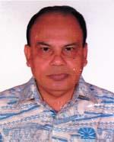 | DR. MUHAMMAD FAKHRUL ALAM.  F/Name: Mr. Abul Hasem Mia.  M/Name: Mrs. Akimon Khatun.  BM & DC Reg. No: 14574  NID: 0695114202140  Cell: 01711358980  Address: N/A  Blood Group: B+
271 | Voter No  LM-0400271  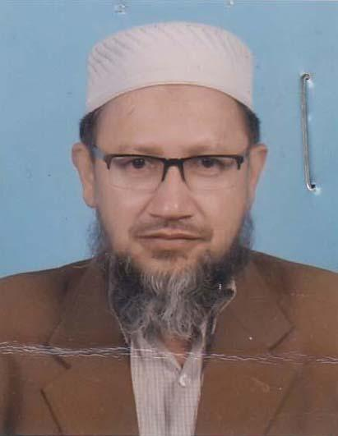 | DR. MD. MAHMUD HASAN KHAN  F/Name: Late. Belal Hussain Khan  M/Name: Late. Saleha Begum  BM & DC Reg. No: 21423  NID: 6893085305  Cell: 01711946876  Address: Paediatrics OPD SBMCH, Barisal.  Blood Group: O+
272 | Voter No  LM-0400272  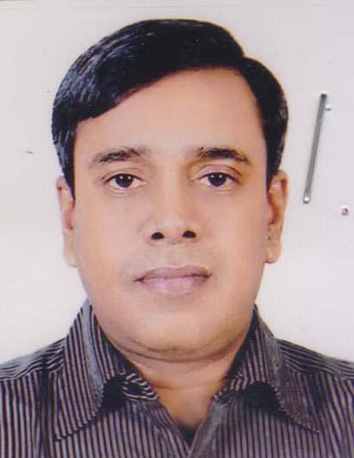 | DR. S. M ZAHID HASAN  F/Name: Md. Ali Hossain Sikder  M/Name: Razia Begum  BM & DC Reg. No: 28972  NID: 6443132706  Cell: 01711-287572  Address: “Niloy”, College Road, Barisal.  Blood Group: O-

